CHAPTER 2

The word ‘gay’ has been used now for decades in an attempt to replace the more descriptive word ‘homosexual.’ The term homosexual is descriptive of a specific type of sexual behaviour; men having anal intercourse (previously called sodomy) with other men. While ‘homosexual’ is the proper descriptive term, it is not the word picture the homosexual community wishes to paint.

Half a decade ago, to be gay, meant to be happily excited. Gay meant to be merry, cheerful; *in a gay mood;* beingkeenly alive and exuberant orhaving high spirits.[1] Now there is an alternative meaning, in fact we are usually hesitant now to use the word in its original form. Instead it refers to, or is characterized by sexual or romantic attraction to people of one's same sex; i.e. *gay* men.[2]

The repositioning of the word ‘*gay*’ was strategic. It succeeded in making homosexuality more acceptable to the general public. Gay is now used to depict a behaviour that initially causes pain and over time collapses the muscles of the rectum. The practice of men having sex with men precipitates many sexual diseases, cancers and early death.

Health concerns for this small minority of the population are vast.[3] Relationships have been demonstrated between anal intercourse and anal cancer in gay men.[4] The Center for Disease Control 2001–2006 indicated that young men who have sex with men were the only risk group with an increasing number of HIV/AIDS diagnoses; the increase was an *alarming 93 percent among young black men*.[5]

According to a 2009 Canadian study, the documented life span of the average homosexual male is about *20 years shorter than that of the general public*. The study found that life expectancy at age 20 for gay and bisexual men ranged from 34 to 46 years and estimated that nearly half of gay and bisexual men would not reach their 65th birthday.[6] Physical and mental health amongst LGBT individuals is far more compromised that many are prone to acknowledge.[7] Minimizing these statistics puts this group of people at further risk. How can a sexual behaviour that causes such health risk be considered *gay*?

Have you ever wondered the meaning of some of the colours of the LGBTQ+ flag and what our country and affirming nations of the world are celebrating? I’m about to explain, and let me tell you we all have a lot to learn. Let’s start with the easy part first.

The abbreviation LGBT stands for Lesbian, Gay (Homosexual), Bisexual and Transgender. These terms started to be used in the 1990’s. The LGBT acronym was created as a way to describe people with different sexual orientations and has become adopted into the mainstream as an umbrella term for sexuality and gender.

The six-colour rainbow flag (red, orange, yellow, green, blue and purple) was originally introduced by Gilbert Baker in 1978 and has commonly been used as a way of showing identity or support.[8] We now have flags with added colours to show support for the following identities:

* 6 colour rainbow – Lesbian, Gay, Bisexual and Transgender
* Blue/Purple/Hot Pink – Bisexual (person who is ***sexually attracted to both*** men and women)
* Blue/Yellow/Hot Pink – Pansexual (person who is ***not limited in sexual choice*** about biological sex, gender or gender identity)
* Purple/White/Grey/Black – Asexual (person who ***does not have sexual feelings or attractions***)
* Purple/White/Green – Genderqueer (person who ***identifies with neither***, both or a combination of male and female genders
* Green/Brown/Blue - Sapiosexual (person who finds ***intelligence***sexually attractive or arousing)

Oh, baby we’ve come a long way from Noah’s Ark. But we are far from done yet. The language around gender and sexuality is exploding. As my dad would say, it’s… ed-ja-meca-tion time! Let’s begin.



**Androphilia:**  This flag depicts the love of men, a sexual attraction to men or masculinity by people of any sex or gender.[9]

**Androgynous:** A person having characteristics or nature of both male and female or reversing traditional male and female roles[10]

** Asexual:** An Asexual individual is someone who feels little or no sexual attraction.

**Autosexual:** This is when one experiences sexual attraction primarily or exclusively towards oneself. It can occur in different forms such as a person who has difficulty responding to another’s sexual touch, but is comfortable with self-pleasing (masturbation).[11] Experiencing romantic feelings towards oneself is called autoromantic.

**Aromatic:** An Aromatic has little or no romantic feeling toward others: experiences little or no romantic desire or attraction.

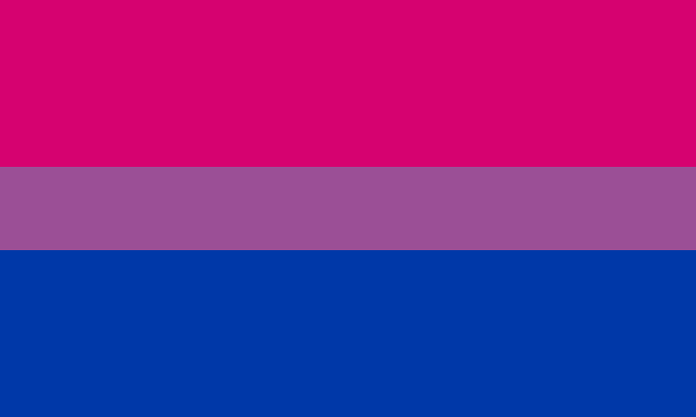

**BiSexuality** is characterized by a sexual or romantic attraction to both the same sex and the opposite sex.



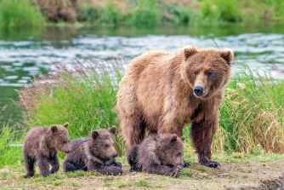**Bear:** This newer term is used for men homosexual men who exhibit a specific set of physical traits, such as a large, sturdy build, facial and body hair.[12] The image of a bear in this context is of a man who exemplifies masculinity in a rugged sense of the word. There are other terms attributed to men who have sex with men that derive from the animal concept. One of these is ***cub***. The name cub in LGBT terms means a young man. The original meaning in nature is a *baby bear*.

**\*1BDSM Pride:** The bondage and sadomasochism flag looks almost identical to the gynephilia flag but the mean is entirely different. BDSM stands for Bondage, Domination, Sadism (deriving sexual gratification by inflicting psychical

pain or emotional abuse; extreme cruelty[13]), and Masochism (deriving sexual gratification by allowing oneself to be physically or emotionally abused[14]).

According to the Merrium-Webster dictionary BDSM is a sexual activity involving practices that use physical restraints; the granting and relinquishing of control over the person, and the infliction of pain.[15] Simply put it’s all about domination and control. BDSM is considered to be part of *Kink* or *kinking*.[16] Kink refers to any unusual taste in sexual behaviour. Behaviour in this category used to be considered deviant and abnormal. Now it’s celebrated.

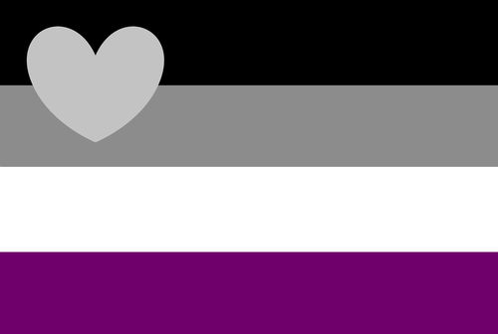

**Demiromantic:** Thisdescribes person who is romantically attracted only to people with whom they already have an emotional bond.[17]

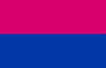**Gender Binary:** Heterosexual or ‘straight’ individuals (now called cisgender) have their own flag! I wasn’t aware of the need for one, but nevertheless, here it is. Gender binary refers to those that believe there are only two sexes, male and female.

**Gender fluid:** these are individuals who declare [gender identity](https://www.merriam-webster.com/dictionary/gender%20identity) is not fixed, but instead it is fluid, meaning it fluctuates depending on mood and circumstance. Sometimes individuals call themselves queer or question, but gender fluid have decided that they are not relegated to a particular label.



**Gender Non-binary** is an umbrella term to describe any gender identity that does not fit into a biological male and female identity. These people describe themselves as not exclusively man or woman - having no gender, and fall on a gender spectrum (Kinsey scale shown below) somewhere between male and female, or identify as totally outside binary gender identities.[18]

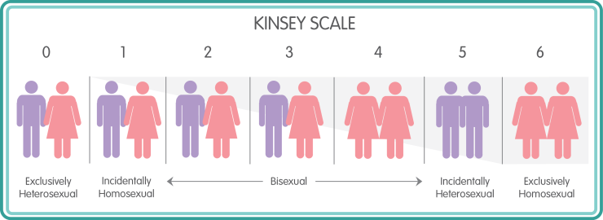

Before I continue with the flags, I want to explain a little about Alfred Kinsey (1984-1956). Kinsey made many false allegations in his famous study (in 1949). He used his ‘*random sample*’ of 4120 men included nearly 1,000 present and former inmates (25%); many of whom were homosexual and/or pedophiles[19]. From this bias sample Kinsey determined that 37% of the total male population (in the US) has some sort of overt homosexual experience and 13% of the population was predominantly homosexual[20]. Studies in six different nations from 1987 to 2002 show that only 3.1% of men and 3.3% of women *have ever had* a homosexual experience in their entire lives — even if it was only one such experience.[21] For more information on Kinsey, the LGBTQ and the indoctrination of our children see, *Closing the Floodgates: Setting the Record Straight on Gender and Sexuality.[22]*



**Greyromantic’s** infrequently experience romantic attraction although it is considered a weak attraction. Even if they are attracted they may not desire a relationship or only find attraction in specific circumstances.[23]

**Gynephilia:** This is the opposite of Androphilia (the love of men). Gynephilia represents someone who is attracted to femininity; a sexual attraction to women and female characteristics. Either men or women can be a gynephilic.

**Hermap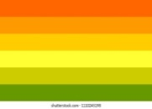hrodite:** This is an older term used to describe a person in whom the sexual characteristics of both sexes are to some extent, combined. These individuals are more often called intersex.



**“Intersex**” is the term that a person uses when someone has under developed male and/or female sex characteristics. This term encompasses several different diagnostic criteria for a biological anomaly. Characteristics of the disorder include genitalia, hormones, chromosomes, and reproductive organs. Being intersex is not a disease. It is extremely rare, and occurs in pre-birth development. Having an intersex condition is medical diagnosis, ***NOT an identity.***

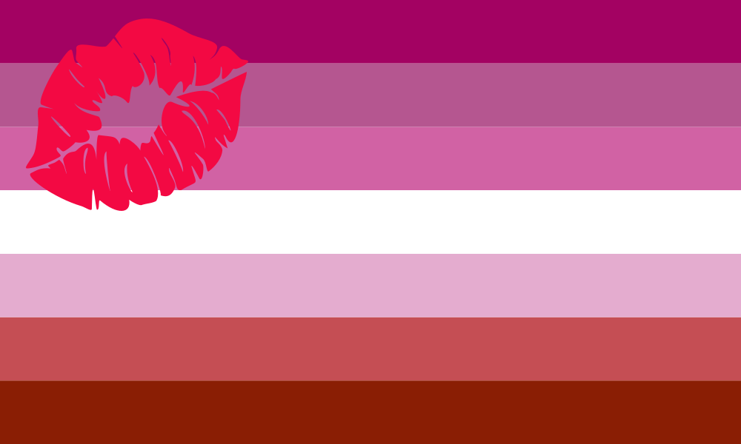**Lipstick Lesbian:** is a term used for a woman sexually attracted to other women who dress in a traditionally feminine manner. This is a lesbian who has glamorously feminine characteristics, as opposed to the stereotypically masculine lesbian.[24] A lipstick lesbian, strictly speaking, is attracted to feminine women.



**Neutrois:** According to Gender Wiki having a null or neutral gender, not [male](https://www.wordnik.com/words/male), [female](https://www.wordnik.com/words/female), or [androgynous](https://www.wordnik.com/words/androgynous) but possibly [genderqueer](https://www.wordnik.com/words/genderqueer). Neutrois is associated with genderless-ness, and shares many similarities with agender.[25]

**Pansexual:** Thisperson is characterized by sexual or romantic attraction that is not limited to people of a particular sex, gender identity or sexual orientation[26]



**Polysexual:** A polysexual person is someone who is sexually and/or romantically attracted to multiple genders. This is a separate designation from being bisexual or pansexual, even though these sexualities involve being attracted to more than one sex or gender. [27] Apparently being polysexual is not the same as being polyamorous.

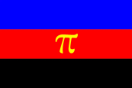

**Polyamorous:** According to Flagwixthe poly flag features three horizontal colored stripes of equal width, from top to bottom: Blue, Red, and Black. In the center is gold Greek letter “pi.” It represents the first letter in “polyamory.”[28]

This flag represents relationships in which people date multiple partners or have romantic (or/and sexual) relationships with more than one individual at the same time. For polyamory to works it must be based on the consent of all people involved. Handling multiple romantic and sexual affairs at the same time sounds like a road to disaster!

**A Skoliosexual** is sexually attracted to people who identify with a non-binary gender (they feel neither fully male nor fully female). According to the Gender and Sexuality Dictionary skolio- in skoliosexual comes from a Greek root meaning “bent” or “curved,” seen in the word scoliosis.[29] If you remember the root word *bent* is also used when describing Kink alternatives.

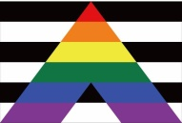**Straight ally**: Also referred to as heterosexual ally. This is a heterosexual individual who supports equal, gender equality for, LGBT folk. They get involved in social movements, and support the concepts of homophobia, biphobia and transphobia. Despite this, some of the people who meet this definition do not identify themselves as straight allies. A straight ally *must believe that LGBT people constantly face discrimination and thus are socially* *and economically disadvantaged.*

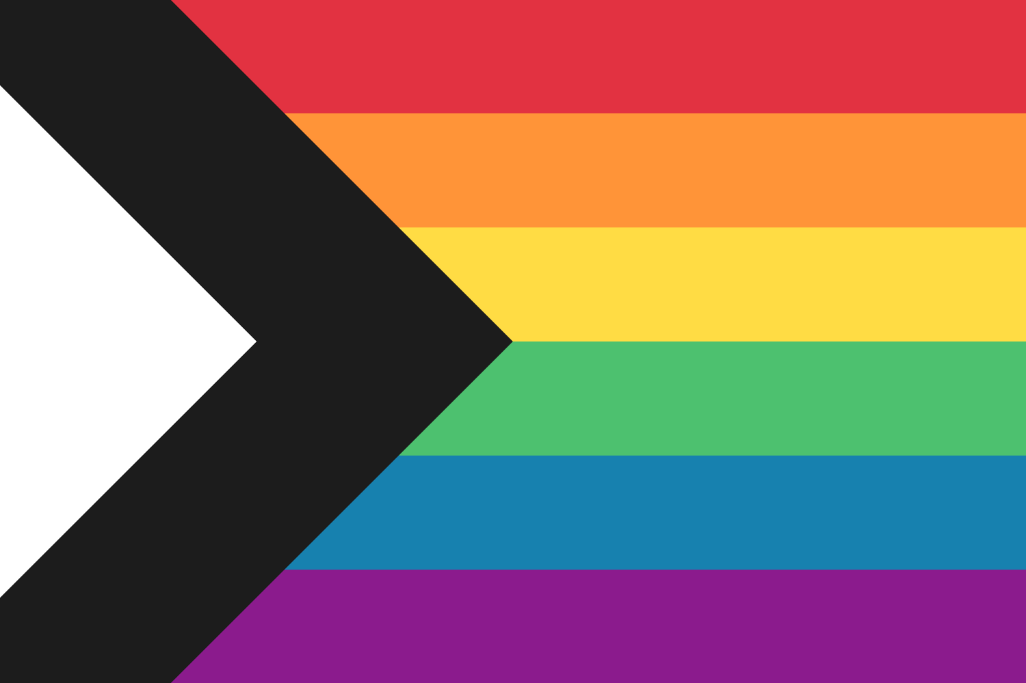**Straight Ally redesign:** This is the most current flag to represent allies. Most LGBT organizations have some straight members involved and actively encourage straight participation. A gay–straight alliance (GSA) is a *student-run club* required in all public education schools. The purpose is to create a platform for activism to promote homosexuality and the transgender identity.[30]

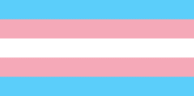

The flags for transsexual and transgender appear to be one and the same. **Transgender:** Identifying as or having undergone medical treatment to attempt to become a member of the opposite sex. Individuals have used medical treatment; puberty blockes, hormones and/or sex reassignment surgery in an attempt to align their biological sex with their gender dysphoria feelings.

**Transsexual*2.** Transsexual is the word that transgender has replaced.

NOTE: Transsexual people may or may not undergo surgery and hormone therapy to obtain a physical appearance typical of the gender they identify as.[31]



**Twink:** TheTwink flag doesn’t have a set definition for each colour. It is assumed that the pink colour depicts more feminine or effeminate traits. The interlocking symbols in the center represent male to male sexual attraction.[32] Twinks are teen and adolescent men who have a slim physique and youthful appearance.[33]

***The Paraphilia’s***

**\*1 BDSM.** In the discussion about bondage and domination, I want to bring attention to the Diagnostic and Statistical Manual DSM-VI (also called the psychological bible) criteria for Sexual Masochism Disorder and Sexual Sadism Disorder.

The diagnostic criteria for *Sexual Masochism Disorder* are intended for those who openly admit having such paraphilic interests, acknowledging intense sexual arousal from the act of being humiliated, beaten, bound or otherwise made to suffer. If such individuals suffer psychological difficulties because of their sexual attractions or preferences they may be diagnosed with this disorder. On the other hand if they *do not feel distressed*, they could be ascertained as having masochistic sexual interest, but *should not be diagnosed* with the disorder.[34]

The diagnostic criterion for Sexual Sadism Disorder applies both to those who freely admit to having such paraphilic interests and those who deny such interests, despite objective evidence to the contrary. Individuals reporting intense sexual interest in the physical or psychological suffering of others can be diagnosed with sexual sadism disorder. If admitting individuals declare no distress exemplified by anxiety, obsessions, guilt or shame about these impulses and psychiatric or legal histories indicate they do not act on them, they could then be ascertained as having sadistic sexual interest, but not sexual sadism disorder.[35]

**\*2Transexual.** *Transsexualism* was included for the first time in the Diagnostic and Statistical Manual [DSM-III](https://en.wikipedia.org/wiki/DSM-III) in 1980.[36] The eleventh revision of the International Classification of Diseases (ICD), was published in 2018 by the World Health Organization. This new revision of the ICD-11 has **abolished the codes** of *Gender Identity Disorder* and *Fetishistic Transvestism* among other sexual practices[37], once considered as paraphilia’s.[38] These codes have been replaced in part by gender incongruence**,** which refers to conditions that classify under the term gender dysphoria.

This is a major paradigm shift. Gender variant behavior and preferences alone are no longer a basis for assigning a Gender Identity Disorder or Gender Dysphoric diagnosis. This shift has profoundly changed the way Science and Psychology views transgender people and transsexuals.[39] This shift in diagnosing has removed the stigma related to being referred to as people who “*suffer from paraphilia’s.”[40]* I believe in doing so the DSM has unfortunately left such individuals adrift, like a ship without a rudder, by neither providing an adequate diagnosis nor much needed psychological care. There are many co-morbid mental illnesses observed in this group including a large percentage of the Gender Dysphoric that fall within the autism spectrum.

One diagnosis still included in the DSM-VI is **Transvestic Disorder**.[41] This disorder observed primarily in men who cross dress (i.e. drag queens), includes sexual fantasies and sexual urges, but must cause clinically significant distress. According to the DSM transvestic disorder is often accompanied by ***autogynephilia*** (a man’s tendency to be aroused sexually by the thought or image of himself as a woman). [42]

***Autogynephilia*** was first identified by Toronto based sexologist, Dr. Ray Blanchard. To read more on this long neglected aspect of transvestites see Blanchard’s Augogynephilia theory.[43] Blanchard’s extensive studies also include pedophilia and sexual orientation. Dr. Blanchard's works have been cited more than 14,000 times.[44] Nevertheless autogynephilia is no longer addressed when treating the gender dysphoric. Blanchard has instead been thrown under the bus and reported by Southern Poverty Law, as a far-right scientist and academic, associated with supposedly pseudoscientific theories![45]

One last diagnosis that I want to quickly discuss while we are on the subject of paraphilia’s, is that of ***Pedophilia***. It comes right after sexual sadomasochism in the DSM-VI. While there are some that might take offense at my including this diagnosis here, I want to remind you that it is relevant to the conversation.

Pedophilic Disorder diagnosis can only be given if:

1. the individual has experienced six months of recurrent, intense, sexually arousing fantasies, sexual urges or behaviours involving sexual activity with a pre-pubescent child or children;
2. has acted on these behaviors, or the urges and fantasies cause marked distress
3. the individual is at least 16 years of age and at least five years older than the child.[46]

If the individual is in late adolescence involved in an ongoing sexual relationship with a 12 or 13 year old they are not considered eligible for the diagnosis.[47] The criteria for diagnoses are similar to transvestic disorder. The diagnosis applies to individuals who freely disclose and individuals who deny sexual attraction to pre-pubescent children. Also if they report these attractions are causing psychological difficulties they may be diagnosed.[48]

However if they report an *absence of feelings of guilt, shame or anxiety about these impulses* and are not functionally limited by their paraphilic (pedophilic) impulses and their recorded histories indicate they have never acted on such impulses, these individuals have a ***pedophilic sexual orientation,*** but ***not a pedophilic disorder***![49] Read this again. A pedophilic sexual orientation, what does that mean? After it’s declared to be an orientation it then becomes legal – think of the term of *born that way*.

If you thought the waters were getting muddied by all the colours under the rainbow and your mind was over saturated that was just the beginning. By now I expect you may feel like you’re swimming in quicksand. I know that at times I feel this way. All the information is overwhelming. Imagine how our children must feel.

I believe we need to understand all that is being represented when we celebrate PRIDE. It seems to me there is a very fine line between *acceptable deviance and unacceptable sexual behavior.*

References

Centers for Disease Control and Prevention. (2010). Sexually Transmitted Disease surveillance 2009. Atlanta: U.S. Department of Health and Human Services.

Diamant, A.L., Wold, C., Spritzer, K., & Gelberg, L. (2000). Health behaviors, health status, and access to and use of health care: A population-based study of lesbian, bisexual, and heterosexual women. *Archives of Family Medicine, 9,* 1043–1051.

Frisch, M., & Brønnum-Hansen, H. (2009). Mortality among men and women in same-sex marriage: A national cohort study of 8333 Danes. *American Journal of Public Health, 99*(1), 133–137.

Frisch, M., Smith, E., Grulich, A., & Johansen, C. (2003). Cancer in a population-based cohort of men and women in registered homosexual partnerships. *American Journal of Epidemiology*, *157*, 966–972.

Grossman, M. (2013b). R18 report: Sexuality education in New Zealand: A critical review. Retrieved from [www.bobmccoskrie.com/wp-content/](http://www.bobmccoskrie.com/wp-content/) uploads/2013/06/Miriam-Grossman-R18-Report.pdf

Hogg, R.S., Strathdee, S.A., Craib, K.J., O’Shaughnessy, M.V., Montaner, J.S., & Schechter, M.T. (1997). Modelling the impact of HIV disease on mortality in gay and bisexual men. *International Journal of Epidemiology, 26*(3), 657–661.

1. [Gay Definition & Meaning - Merriam-Webster](https://www.merriam-webster.com/dictionary/gay)
2. Ibid
3. Frisch, Smith, & Johansen (2003)
4. Diamant et al (2000)
5. Centers for Disease Control and Prevention (2010)
6. Hogg et al (1997)
7. Frisch & Brønnum-Hansen (2009)
8. [LGBT+ colours and their meanings - Butler and Grace Ltd](https://butlerandgrace.co/blogs/news/lgbt-colours-and-their-meanings#:~:text=6%20colour%20rainbow%20%E2%80%93%20Lesbian%2C%20Gay%2C%20Bisexual%20and,regard%20to%20biological%20sex%2C%20gender%20or%20gender%20identity%29)
9. [Androphilia Flag | Rocky Mountain Flag Company](https://rockymountainflag.com/product/androphilia-flag/)
10. <https://www.merriam-webster.com/dictionary/androgynous>
11. [Autosexual - LGBTQIA+ Wiki](https://www.lgbtqia.wiki/wiki/Autosexual)
12. <https://www.rd.com/list/lgbtq-flags/>
13. [sadism - definition and meaning (wordnik.com)](https://www.wordnik.com/words/sadism)
14. Ibid
15. [BDSM Definition & Meaning - Merriam-Webster](https://www.merriam-webster.com/dictionary/BDSM)
16. [Kink (sexuality) - Wikipedia](https://en.wikipedia.org/wiki/Kink_(sexuality))
17. <https://www.dictionary.com/browse/demiromantic>
18. <https://www.medicalnewstoday.com/articles/321529#:~:text=Nonbinary>
19. Reisman & Eichel (1990)
20. DuBay (2001)
21. [Homosexuality: Gay, Lesbian, and Bisexual Demographics in the US (hli.org)](https://www.hli.org/resources/prevalence-of-homosexuality-in-the-us/) pg 6
22. Gillies, A. E. (2017). *Closing the Floodgates: Setting the Record Straight on Gender and Sexuality.* Word Alive Press: Winnepeg, Man.
23. [Greyromantic - LGBTQIA+ Wiki](https://www.lgbtqia.wiki/wiki/Greyromantic)
24. [lipstick lesbian - Wiktionary](https://en.wiktionary.org/wiki/lipstick_lesbian)
25. [Neutrois | Gender Wiki | Fandom](https://gender.fandom.com/wiki/Neutrois)
26. <https://www.merriam-webster.com/dictionary/pansexual>
27. [polysexual Meaning | Gender & Sexuality | Dictionary.com](https://www.dictionary.com/e/gender-sexuality/polysexual/)
28. [The Polyamorous Flag Meaning and Reasons It Was Created (flagwix.com)](https://blog.flagwix.com/polyamorous-flag/)
29. <https://www.dictionary.com/e/gender-sexuality/skoliosexual/>
30. <https://www.definitions.net/definition/straight+ally>
31. [Transsexual Definition & Meaning - Merriam-Webster](https://www.merriam-webster.com/dictionary/transsexual)
32. [Sexuality Flags & LGBT+ Symbols: The Ultimate Pride Guide (vispronet.com)](https://www.vispronet.com/blog/sexuality-flags/#TwinkFlag)
33. [Twink (gay slang) - Wikipedia](https://en.wikipedia.org/wiki/Twink_(gay_slang))
34.
35. American Psychiatric Association. (2013). Diagnostic and Statistical Manual of Mental Disorders (3rd ed.). Washington, D.C. pg.695,696.
36. American Psychiatric Association. (1980). Diagnostic and Statistical Manual of Mental Disorders (3rd ed.). Washington, D.C.
37. ["WHO takes bdsm and fetishism off the sick list - Revise F65"](https://revisef65.net/global-milestone-human-rights-reform/). *revisef65.net*.
38. ["ICD-11 - Mortality and Morbidity Statistics"](https://icd.who.int/browse11/l-m/en#%5Bhttp://id.who.int/icd/entity/2110604642). *icd.who.int*.
39. Ibid
40. Ibid
41. American Psychiatric Association. (2013). Diagnostic and Statistical Manual of Mental Disorders (5th ed.). Washington, D.C. pg. 701-703
42. Ibid
43. [Blanchard's Autogynephilia Theory: a critique - PubMed (nih.gov)](https://pubmed.ncbi.nlm.nih.gov/20582803/)
44. [Ray Blanchard - Wikipedia](https://en.wikipedia.org/wiki/Ray_Blanchard)
45. Ibid
46. American Psychiatric Association. (2013). Diagnostic and Statistical Manual of Mental Disorders (3rd ed.). Washington, D.C. pg. 697,698.
47. Ibid
48. Ibid
49. Ibid